Reading Assignment 3
Section 1.1
- What is life?
Life is the ability to metabolize nutrients, respond to external stimuli, grow, reproduce, and, most importantly, evolve. Most of these functions are performed by proteins, organic macromolecules involved in nearly every aspect of the biochemistry and physiology ofliving organisms. They can serve as structural material, catalysts, adaptors, hormones, transporters, regulators. Chemically, proteins are linear polymers of amino acids, a class of organic compounds in which a carbon atom (called Cal is bound to an amino group (-NHz), a carboxyl group (-COOH), a hydrogen atom (H), and an organic side group (called R). The physical and chemical properties unique to each amino acid result from the properties of the R group
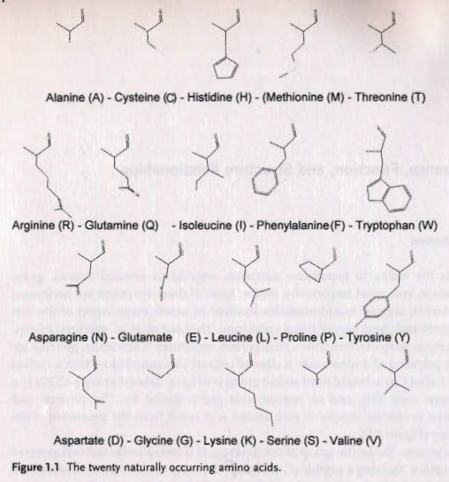
- What is special about a peptide bond?

In a protein, the amino group of one amino acid is linked to the carboxyl group of its neighbor, forming a peptide (C-N) bond. There are two resonance forms of the peptide bond (i.e. two forms that differ only in the placement of electrons), as illustrated in Figure 1.2. Atoms involved in single bonds share one pair of electrons whereas two pairs are shared in double bonds. The latter are planar, i.e. not free to rotate. The resonance between the two forms shown in Figure 1.2 makes the peptide bond intermediate between a single and a double bond and, as a consequence, all peptide bonds in protein structures are found to be almost planar- the Ca, C, and 0 atoms of one amino acid and the N, H, and Ca of the next lie on the same plane. Although this rigidity of the peptide bond reduces the degrees of freedom of the polypeptide, the dihedral angles around the N'-:Ca and the Ca-C bonds are free to vary and their values determine the conformation of the amino acid chain
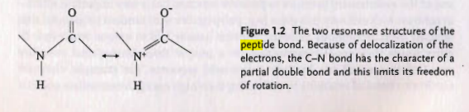
- What kind of protein is pepsin?

Our body contains many proteins that catalyze the hydrolysis of peptide bonds in proteins (the inverse ofthe polymerizing reaction used to build proteins) to provide the body with a steady supply of amino acids. The substrates ofthese reactions are either proteins from the diet or "used" proteins inside the body. Digestion begins in the stomach where the acidic environment unfolds, Le. destructures, the proteins and an enzyme called pepsin (Figure 1.3) starts chopping the proteins into pieces. Later, in the intestines, several protein-cutting enzymes, for example trypsin (also shown in Figure 1.3), cut the protein chains into shorter pieces. In subsequent steps, other enzymes reduce these shorter pieces to single amino acids.
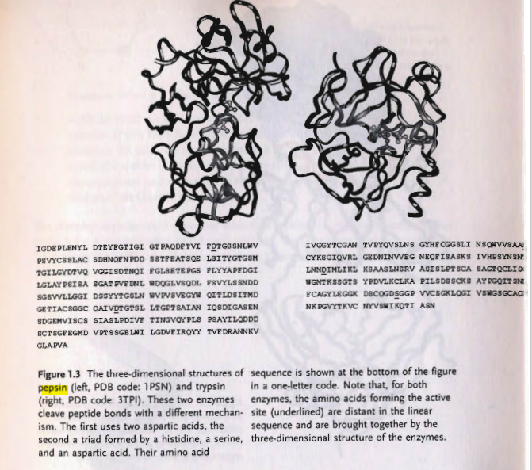

- How many residues are there between both D's of the active site of pepsin?
Both pepsin and trypsin belong to a class of enzymes called proteases, the first performs its job by taking advantage of the presence, in a cleft of the protein structure of two residues of aspartic acid; in the second catalysis is achieved by cooperation ofthree amino acids, a serine, a histidine, and an aspartic acid. Amino acids near the active site are responsible for recognition and correct positioning of the substrate. These functional amino acids, far apart in the linear amino acid sequence (Figure 1.3), are brought together in exactly the right position by the protein three-dimensional structure.

- What do antibodies and proteases have in common?

Similarly, recognition offoreign molecules is mediated by several proteins ofthe immune system, the most popular being antibodies. Antibodies bind other molecules, called antigens, by means of an exposed molecular surface complementary to the surface ofthe antigen, which can be a protein, a nucleic acid, a polysaccharide, etc. The binding surface is formed by amino acids from different parts ofthe molecule (Figure 1.4).
